1. Tried to build android platform based application. Solidity language as well as web3js are still in development stages and as per deploying smart contract on android, I couldn’t find any possible criteria…. all I could find is building web Dapp.
2. To generate byte code as well as ABI which inturn is a Json file since I had problems with solcjs on my system. I preferred using remix browse to carry out these tasks…
3. Smart contract is at remix browser all the details entered by the user on web based UI are reflected back and is shown in video and pics of its execution....
4. 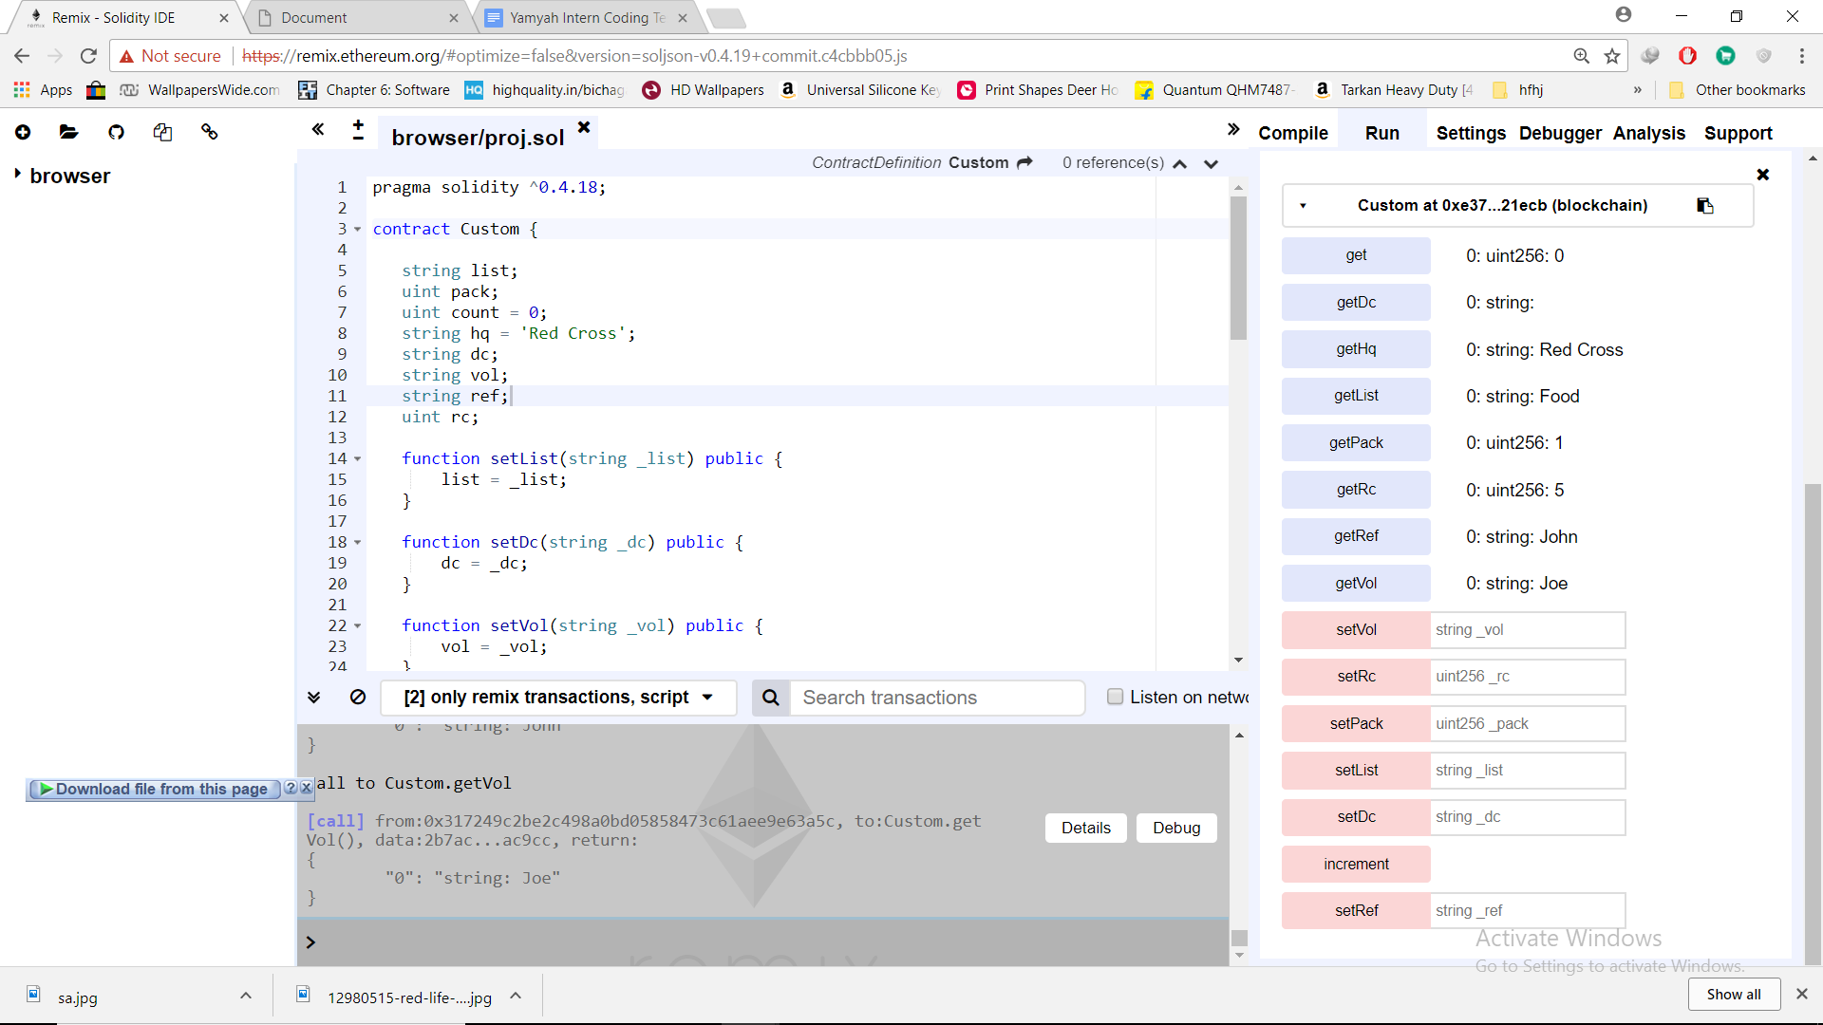
5. 2nd pic even value set-fields are not set, we got output. Set func calls performed on web dapp. Where user entered the data…